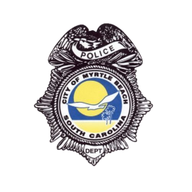

FOIA Request Form
City of Myrtle Beach Police Department
Date of request: ____/______/__________ FOIA Number: ________ (Office Only)
Requestor information
Name: ___________________ Company or Organization: ______________________________
Telephone number: (_____)____-_____________ E-mail: ______________________________
Mailing address: _______________________________________________________________
Intended use of information requested: ______________________________________________
Preferred format (storage drive, print, electronically, etc.): ______________________________
Description of records
Report number: __________ Date: ___________________ Time: _____________
Location: _______________ Names of persons involved: ____________________
Officers name: ______________ Other Document: _________________________
Frequently requested records (please select):

- Incident Report
- Officer’s dash cam audio/video
- Scene Photos
- CAD Report
- 911 phone calls of accident/collision
- Arrest Report
*Body camera footage is exempt from release under FOIA per state law.

Additional description or other request: ____________________________________________________________________________________________________________________________________________________________________________________________________________________________________________________________________________________________________________________________________________________________________________________________________________________________________________________________________________________
For questions and additional information, please contact the Myrtle Beach Police Department FOIA Coordinator at 843-918-1535 or email mbpdfoia@cityofmyrtlebeach.com or Public Information Officer by email at tvest@cityofmyrtlebeach.com

